
Australia’s National
Science Agency
Persistent Identifiers for Instruments – AuScope Web Application
  - User Guide
Pavel Golodoniuc, Benyamin Motevalli, Neda Taherifar
20 May 2026

Copyright
© Commonwealth Scientific and Industrial Research Organisation 2026. To the extent permitted by law, all rights are reserved and no part of this publication covered by copyright may be reproduced or copied in any form or by any means except with the written permission of CSIRO.
Important disclaimer
CSIRO advises that the information contained in this publication comprises general statements based on scientific research. The reader is advised and needs to be aware that such information may be incomplete or unable to be used in any specific situation. No reliance or actions must therefore be made on that information without seeking prior expert professional, scientific and technical advice. To the extent permitted by law, CSIRO (including its employees and consultants) excludes all liability to any person for any consequences, including but not limited to all losses, damages, costs, expenses and any other compensation, arising directly or indirectly from using this publication (in part or in whole) and any information or material contained in it.
CSIRO is committed to providing web accessible content wherever possible. If you are having difficulties with accessing this document please contact csiro.au/contact.

Contents
Acknowledgements 2
1 Introduction 3
2 Data Schema 4
2.1 PIDINST Schema 4
2.2 Adjustments to the Schema 4
2.3 Publishing to DataCite 5
2.4 Versioning 5
2.5 Platforms: Arrays of instruments 6
3 Controlled Vocabularies 7
4 Home Page 8
4.1 Login 10
4.2 Core Concepts 10
5 Instruments 12
5.1 Instrument Search 12
5.2 Private and Public Records 14
5.3 Create / Update / Delete Instruments 15
5.4 Versioning 16
6 Platforms 18
6.1 Platforms Search 18
6.2 Create / Update / Delete Platforms 20
7 Parties 22
7.1 Parties Search and Browse 22
7.2 Create / Update / Delete a Party 23
8 Taxonomy 26
8.1 Taxonomy Search and Browse 26
8.2 Create / Update / Delete a Taxonomy 27
9 References 32

Acknowledgements
This work is supported through AuScope and is funded by the Australian Government through the National Collaborative Research Infrastructure Strategy, NCRIS.

Introduction

The PIDINST web application is an instrument registry designed specifically for AuScope-funded and AuScope-owned scientific instruments.
It provides a central place to record, manage, and publish structured information about instruments in the AuScope research infrastructure network. The application helps ensure that these instruments are clearly described, discoverable, traceable, and reusable across research projects and datasets.
The registry is based on the PIDINST metadata standard, which supports persistent identification of instruments. The PIDINST metadata captured in the application is also mapped to the DataCite Metadata Schema 4.7, enabling instrument records to be published and assigned Digital Object Identifiers (DOIs). It allows users to capture key information, including instrument name, identifier, type, manufacturer, owner, contacts, funding references, location, lifecycle status, and related organisations.
By using the PIDINST registry, AuScope can improve visibility into its funded and owned instruments, support better data provenance, and make it easier for researchers, partners, and stakeholders to understand which instruments are available, who manages them, and how they relate to broader research activities.

Data Schema

PIDINST Schema
The PIDINST web application uses the PIDINST metadata standard [1] as the foundation for describing AuScope-funded and AuScope-owned instruments. This provides a structured, consistent way to capture the key information needed to identify, describe, manage, and publish instrument records.
The schema captures the main PIDINST information blocks, including:
- Identifier: The persistent identifier assigned to the instrument.
- LandingPage: The web page that users are directed to when resolving the instrument identifier.
- Name: The recognised name of the instrument, ideally meaningful and unique within the managing organisation.
- Owner: The organisation or person responsible for managing, operating, hosting, or providing access to the instrument.
- Manufacturer: The organisation or person responsible for building or producing the instrument.
- Model: The instrument model, type, or model name.
- Description: A summary of the instrument, including its purpose, capabilities, and relevant technical details.
- InstrumentType: One or more classifications describing the kind of instrument being registered.
- MeasuredVariable: The variables, properties, or phenomena that the instrument measures or observes.
- Date: Important lifecycle dates for the instrument, such as when it entered operation or stopped being used.
- RelatedIdentifier: Links to related resources, such as documents, datasets, publications, external metadata records, or related instruments.
- AlternateIdentifier: Other identifiers used for the same instrument in external systems, inventories, catalogues, or registries.

Adjustments to the Schema
The PIDINST schema is used as the base schema, but it has been enhanced to support additional AuScope registry requirements. These enhancements include information about the instrument’s location, funding references, and instrument classification, which provides a high-level category for grouping instruments.
The schema also includes temporal information about the instrument lifecycle. In addition to the standard Commissioned and Decommissioned dates, the application supports a broader Date Range to describe the period during which an instrument was active, available, or relevant to a record.
In the original PIDINST schema, Model and Alternate Identifier are optional fields. However, in the AuScope PIDINST implementation, these fields are mandatory. This is because an organisation may manage multiple instruments with the same or similar name from the same manufacturer. In these cases, the model and an alternate identifier, such as a serial number, asset number, inventory number, or other local identifier, are required to distinguish one instrument from another. A combination of manufacturer, model, and alternate identifier, therefore, helps ensure that each instrument record can be uniquely and reliably identified within the registry.

Publishing to DataCite
For publishing and DOI creation, the enhanced PIDINST metadata is mapped to the DataCite Metadata Schema 4.7. This mapping transforms instrument records into DataCite-compatible metadata so they can be published and assigned DOIs. The mapping follows the official PIDINST-to-DataCite guidance [2], mapping key PIDINST fields such as identifier, name, owner, manufacturer, model, dates, related identifiers, and alternate identifiers to corresponding DataCite properties.

Versioning
The PIDINST application supports versioning to track changes made to instrument records over time. This is important because instrument metadata may change as new information becomes available, such as updates to ownership, contacts, location, lifecycle dates, related resources, or operational status.
In this application, each time a user creates a new version of an instrument record, the system generates a new DOI for that version. This ensures each published version has its own persistent, citable identity. Older versions remain accessible, but they are clearly linked to the newer versions of the same instrument record.
The application maintains relationships between versions so that users can understand the history of an instrument record. When viewing a record, users can see whether other versions exist and can navigate through the version history. If a user opens an older version, the application clearly indicates that they are not viewing the latest version and provides a way to access the most recent version.
This approach helps preserve the integrity of published metadata while still allowing instrument records to evolve over time. It distinguishes between the instrument as a real-world object and the published metadata versions that describe it. Each version can be cited independently, while the application keeps the version history connected and understandable.

DataCite version linkage
The relationship between instrument versions is also recorded in the DOI metadata registered with DataCite. When a new version of an instrument record is published and a new DOI is created, the DOI of the previous version is included as a related identifier.
The related identifier is recorded with:
- Related identifier type: DOI
- Relation type: IsNewVersionOf
- Related identifier: the DOI of the previous version
For example, if a new instrument version with DOI 10.82388/new-version is created from an existing version with DOI 10.82388/previous-version, the DataCite metadata for the new DOI includes the previous DOI with the relationship IsNewVersionOf.
This means the version relationship is not maintained only within the PIDINST application; it is also represented in the DOI metadata itself. Systems that consume DataCite metadata can therefore identify that the newer DOI represents a new version of an earlier published instrument record.

Platforms: Arrays of instruments
The PIDINST website clearly distinguishes between Instruments and Platforms, even though both record types use the same underlying schema. In this context, an instrument represents an individual device or piece of equipment, while a platform represents a configured collection of instruments used together for a particular purpose.
This distinction is important in geoscience applications, where scientists often combine the same instruments, or selected instruments from a larger set, in different configurations before conducting a survey. For example, a survey platform may consist of several sensors, receivers, transmitters, loggers, or supporting components that are assembled and operated together as a single measurement system.
Therefore, a platform is not necessarily a single physical instrument. Instead, it should be understood as an array or configuration of instruments that work together in a defined arrangement. Recording platforms separately allows users to describe both the individual instruments and the combined systems in which those instruments are deployed. This supports better traceability, especially when instruments are reused across multiple surveys, projects, or configurations.

Controlled Vocabularies
The PIDINST application supports controlled vocabularies to improve consistency, discoverability, and search quality across instrument and platform records. Controlled vocabularies help users select recognised terms rather than entering free-text values, reducing duplication and variation in how similar concepts are described.
For Instrument Type, Platform Type, and Measured Variables, users can select terms from recognised GCMD keywords or from custom hierarchical taxonomies defined within the site. These custom taxonomies allow users to grow their own controlled dictionaries for instruments, platforms, and measured variables, while maintaining structured relationships between broader and narrower terms. This provides flexibility for local AuScope requirements while still supporting consistent metadata entry and improved searchability.
For fields such as Owners, Manufacturers, and Funders, the application uses the concept of Parties. Parties provide a controlled way to manage organisations or individuals associated with instrument records. The Parties system also supports integration with the ROR API, allowing organisations to be linked to recognised Research Organisation Registry identifiers where available.
Together, these controlled vocabularies and party records help ensure that instrument metadata is entered consistently, searched more effectively, and linked more reliably to external standards and registries.

Home Page
This AuScope Instrument Registry acts as a centralised metadata catalogue for describing, managing, and publishing detailed records of AuScope-funded and AuScope-owned scientific hardware. Built on a robust data management framework, the system ensures high discoverability, precise citation tracking, and absolute transparency across research infrastructures by using global persistent identifiers such as DOIs.
The home page is structured to provide an immediate entry point into the catalogue, balancing general exploration with direct search functionalities. Users can navigate the registry through four sections available directly from the header:
- Instruments: The catalogue of individual scientific devices, tracking physical assets, and capturing details such as name, identifier, manufacturer, owner, model, measured variables, location, lifecycle dates, and related resources.
- Platforms: Grouped profiles detailing configurations of multiple instruments working together as a singular deployment system.
- Parties: The registry of administrative stakeholders, hardware manufacturers, funding institutions, and individual points of contact mapped to verified research identifiers (such as ROR).
- Taxonomies: Controlled vocabulary indexes ensuring data consistency and enabling advanced classification filters across all instruments and research sectors.
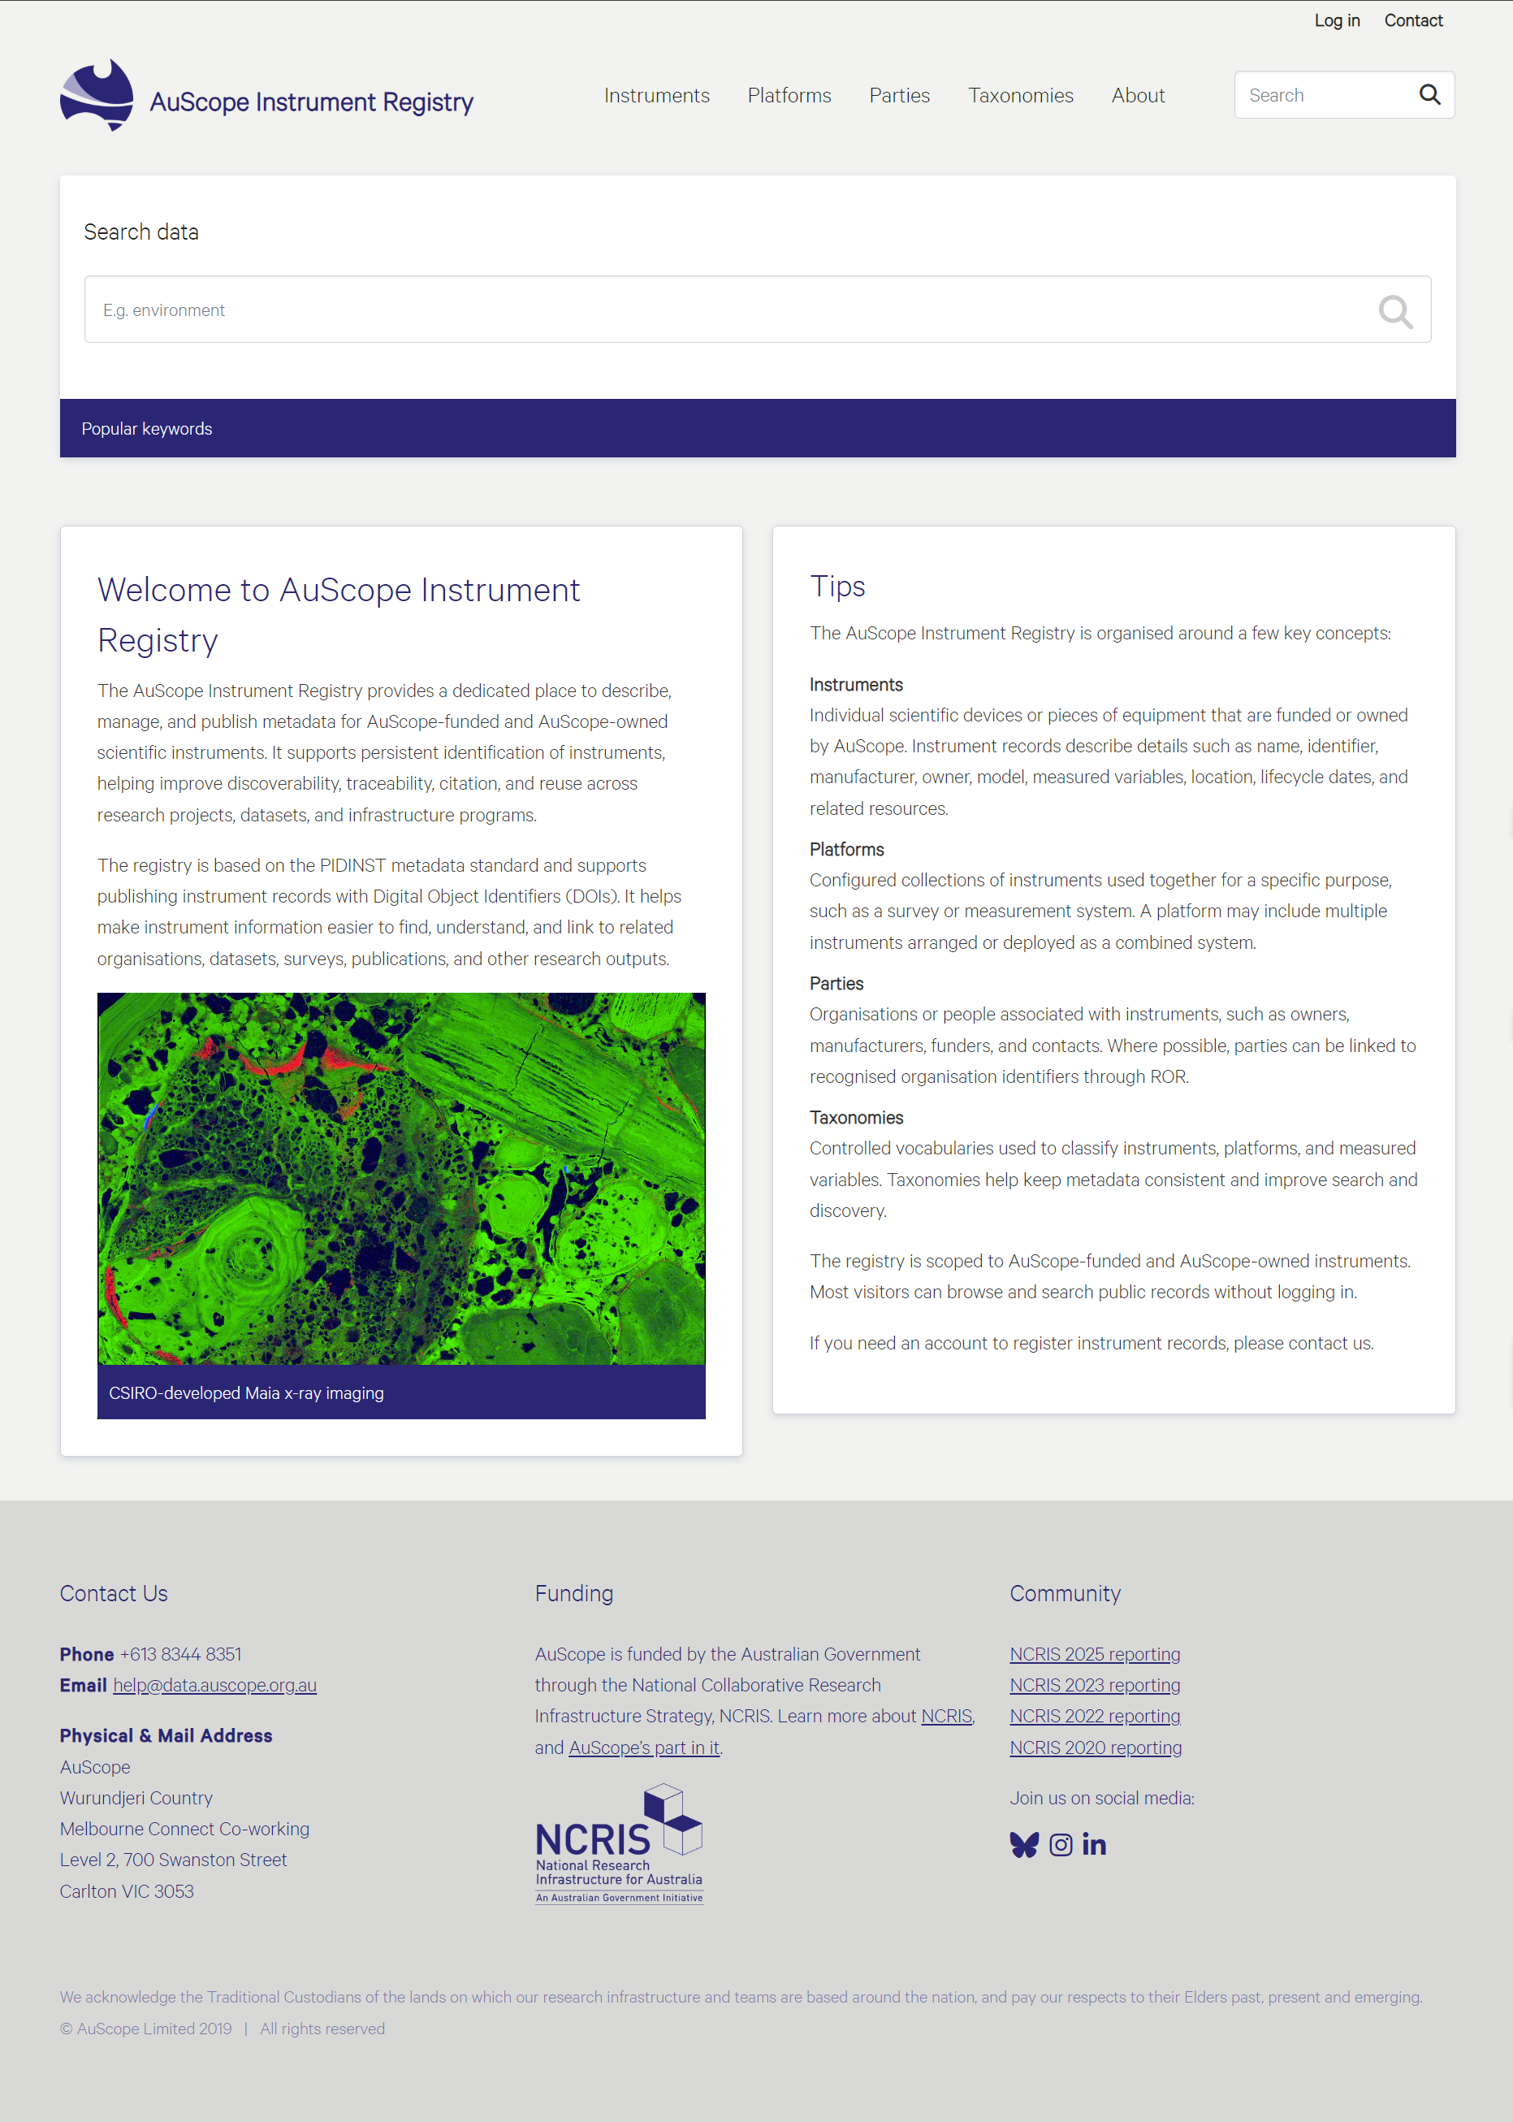
Figure 1 Homepage of the PIDINST application.

Login
While authentication is not required to search, view, or browse the public metadata catalogue, users must register and log in to actively manage data. You must log in to your account to perform the following operations:
- Create new records for instruments, platforms, parties, or taxonomies.
- Update or edit existing private or public records.
- Generate new versions or update instrument version histories.
- Mark as duplicate or withdraw a published public record.

To log in, click the Log In link located in the top-right corner of the homepage header. If you do not have an active account but need to register or manage scientific hardware records, please contact the administration team.

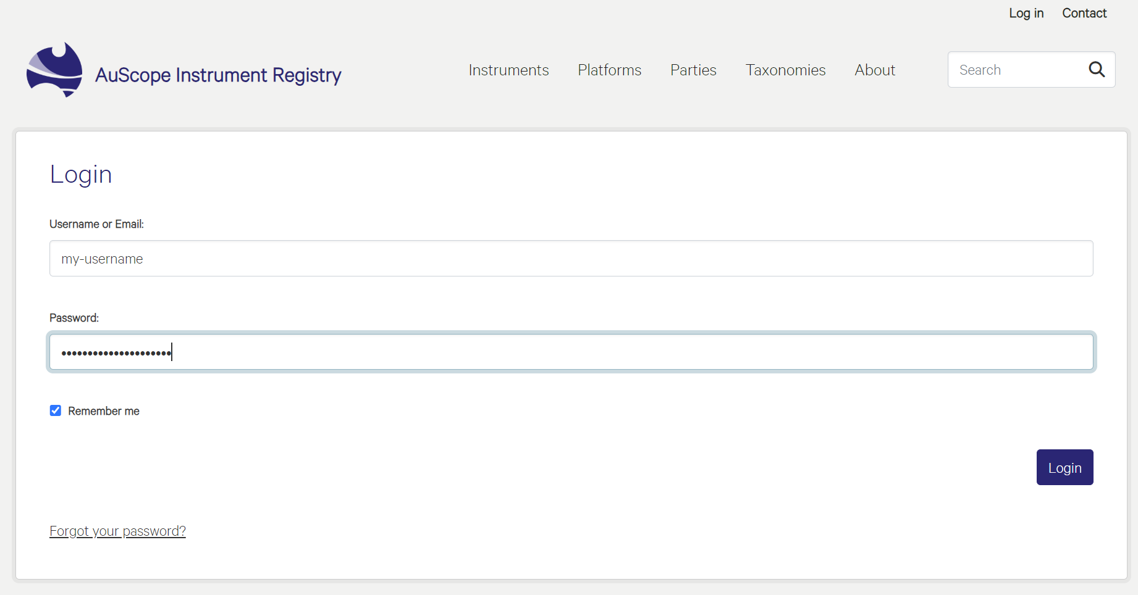
Figure 2 Login screen.

Core Concepts
The AuScope Instrument Registry centres around four core concepts available directly from the header navigation menu. These core registries combine to form an interconnected network of metadata. This network structure delivers maximum data provenance, precise citation tracking, and complete tracking transparency.

Each entity represents a specific type of asset, stakeholder, or controlled classification within the registry:
- Instruments: Individual physical devices or distinct pieces of scientific equipment. This catalogue tracks physical assets and captures structural fields—including unique persistent identifiers, manufacturers, owners, physical locations, operational lifecycle states, and measured variables.
- Platforms: Grouped profiles detailing configurations of multiple instruments working together as a singular deployment system. Platforms allow geoscientists to describe how individual instruments are combined and arranged across different field surveys, arrays, or configurations.
- Parties: The administrative directory of stakeholders associated with instrument lifecycles. This module manages records for equipment manufacturers, funding institutions, administrative organisations, and individual technical contacts, with organisation profiles dynamically integrated with verified global research IDs via the ROR API.
- Taxonomies: Controlled vocabulary indexes that establish system-wide data consistency. Taxonomies provide hierarchical dictionaries for filtering and classifying hardware by scientific sector, instrument types, and measured environmental variables.
The following sections outline the specific browsing capabilities, specialised interface views, and targeted search features unique to each of these foundational sections of the application.

Instruments
The AuScope Instrument Registry provides a multi-layered search and discovery interface that allows users to seamlessly navigate through thousands of research assets. The search layout is optimised to quickly filter instrument arrays and individual scientific hardware using both text-based queries and dynamic facet filters.

Instrument Search
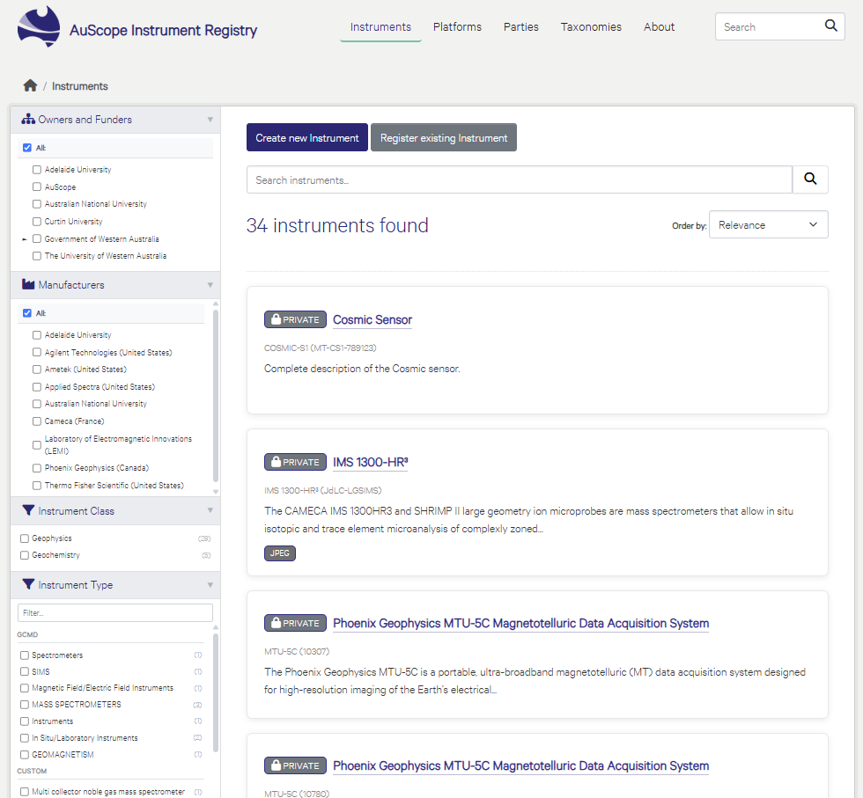
Figure 3 Main Instruments search interface.

Text Search and Multi-Match System
At the centre of the workspace, a smart text search bar allows users to enter keywords that match specific assets.
- Global Keyword Matching: Text queries dynamically scan the database to find partial or absolute matches across fields such as Instrument Name, Model, Internal Asset IDs, and Technical Descriptions.
- Result Ordering: Users can quickly prioritise their results using the Order by dropdown menu in the upper-right corner. Options include ordering records by Name (Ascending or Descending), Relevance, or Last Modified Date.

Active Filter Pills
When user criteria are explicitly checked in the sidebar, they appear as graphical tags directly above the results feed.
- Dynamic Indicators: Each pill shows the selected category alongside its explicit metadata value.
- Instant Removal: Users click the close icon (x) on any individual pill to expand their search parameters.

Faceted Filter Panels
The left-hand sidebar contains expanding facet menus that allow granular data drilling. Each category lists individual parameters, accompanied by a record count indicating how many items fall under that classification. The filtering sections include:
- Owners and Funders: Filter instruments by their managing institutions or funding bodies (e.g., Adelaide University, AuScope, Curtin University, etc.)
- Manufacturers: Isolate hardware by the commercial entity or research laboratory responsible for producing the device (e.g., Ametek, Applied Spectra, etc.)
- Instrument Class: High-level structural categories used to group hardware by major disciplines, such as Geophysics or Geochemistry.
- Instrument Type: Deep hierarchical taxonomy structures mapping to recognised GCMD keywords or custom local labels. Users can expand sub-vocabularies or utilise the dedicated inline text filter to search for obscure classifications (e.g., In Situ/Laboratory Instruments, Magnetotelluric magnetic field sensors).
- Measured Variable: Pinpoint hardware based on the actual physical properties, phenomena, or environmental variables the device is configured to record.

Asset Entry Actions (Authorised Users Only)
For logged-in and authorised users, two administrative buttons are positioned above the primary search workspace to support different registration workflows depending on whether the asset is entirely new or already tracked globally:
- Create a New Instrument: Initiates a step-by-step form to declare a completely new physical asset within the registry metadata schema. Upon successful submission, the system generates a completely new, unique Instrument Identifier (DOI) that permanently anchors and describes this specific piece of hardware.
- Register Existing Instrument: This path is used to register an instrument that already possesses a pre-assigned, globally recognised identity. Instead of creating a duplicate record, the submission process requires the user to input the existing Instrument Identifier to import, link, or reference the device within the AuScope network.

Private and Public Records
The AuScope Instrument Registry features a dual-layer data visibility framework that categorises records as either private or public. This status is initially designated via the Visibility drop-down field during record creation and can be adjusted later by authorised administrators.

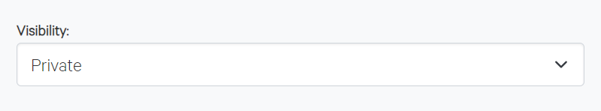
Figure 4 Record visibility drop-down selector.

- Private Records: Private records serve as restricted workspaces visible only to authenticated and authorised users within the managing organisation. They remain hidden from public search and external visitors, allowing teams to safely draft metadata, record internal asset numbers, and verify configurations before publication. A DOI URL is generated and preserved for a private record, but the record is not published to DOI until it is made public.
- Public Records: Once a record is finalised and made public, it becomes part of the open-access metadata catalogue and is published to DOI. Unauthenticated external visitors can browse, search, and view public records to discover available scientific instruments and verify the provenance of research data. If a public record is later changed back to private, the DOI is not retracted or removed; the DOI remains associated with the record.

Create / Update / Delete Instruments
The Create Instrument form provides a comprehensive, multi-section web layout that allows authorised users to document a physical asset's entire administrative, technical, and operational lifecycle.
- Multi-Section Metadata Schema: The user interface groups properties logically into dedicated functional cards—including Core Instrument Details, Owner and Contact Information, Manufacturer Details, Dates, Measured Variables, Funding Sources, and Related Resources.
- Controlled Vocabulary Fields: Standardised fields leverage dropdown components to link assets directly with verified global vocabularies (e.g., NASA GCMD), internal custom taxonomies, and recognised stakeholder registries (Parties).
- Dynamic Component Management: Users can adapt the entry form dynamically using functional controls (e.g., Add Owner, Add Manufacturer, Add Date) to capture multi-institution ownership, complex funding arrangements, or varying structural configurations.
- Workflow Operations: Interactive action buttons at the bottom of the interface manage record status, allowing users to save data as a private workspace iteration or complete the submission process.
- Persistent Identifier Allocation: Upon successful form validation and submission, the application automatically mints a globally unique Digital Object Identifier (DOI). This action permanently anchors the metadata record, enabling cross-platform traceability and data provenance across research infrastructure networks.

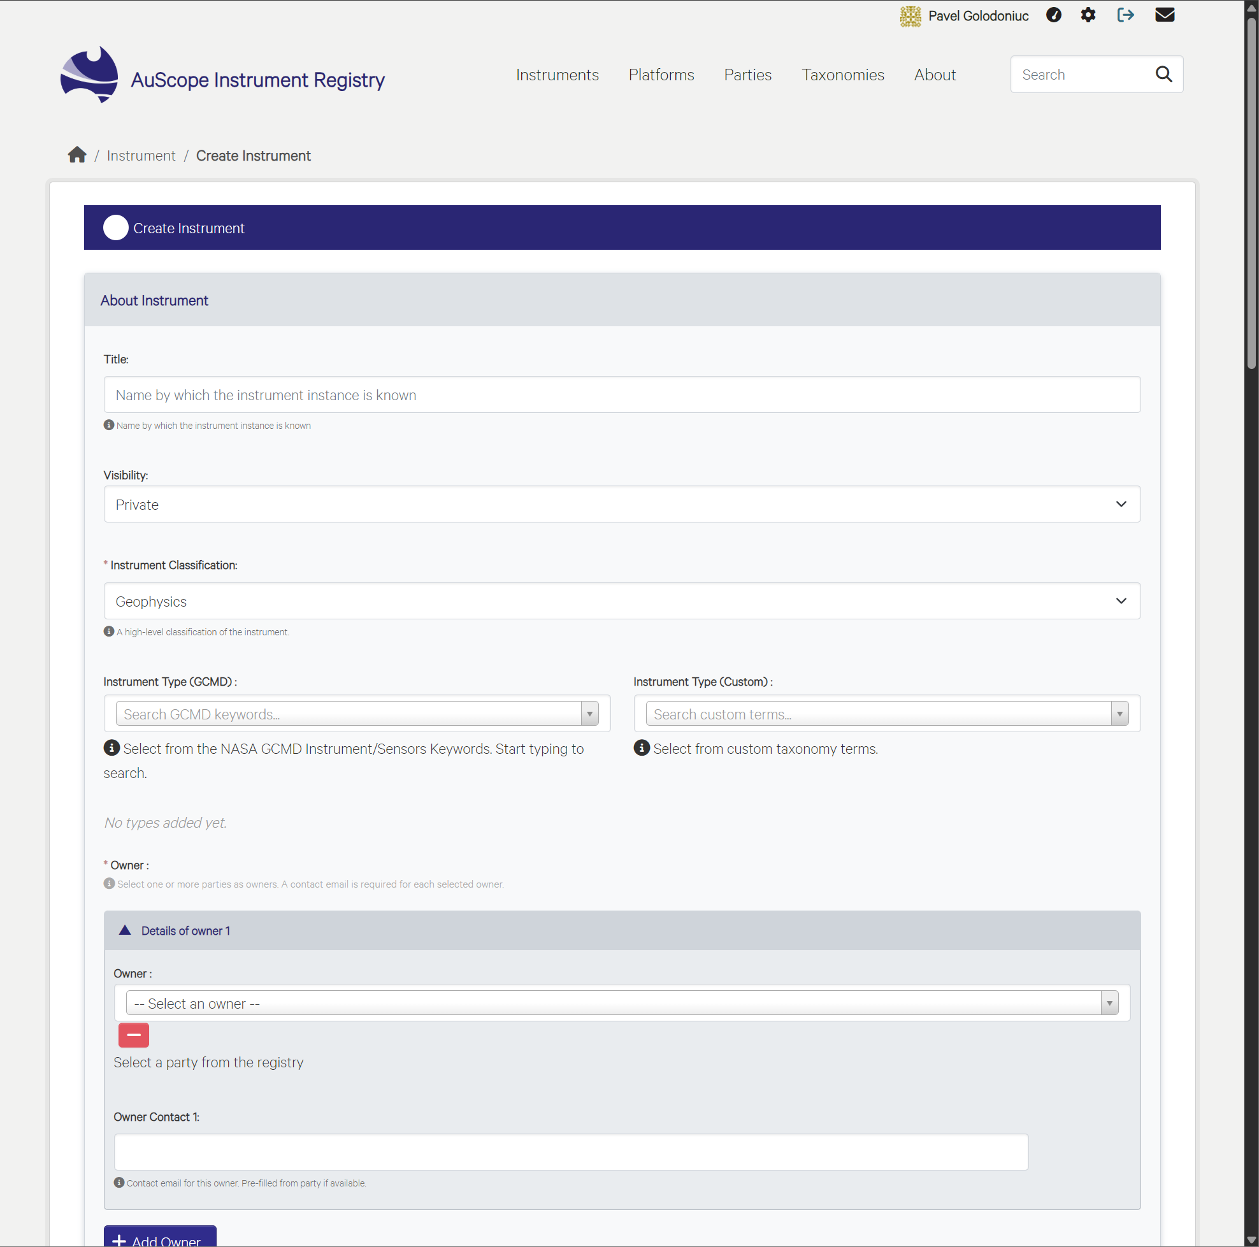
Figure 5 New Instrument record creation interface.

Versioning
Versioning allows authorised users to create a new published record when the metadata for an existing instrument needs to be updated while preserving the previous record as part of the instrument’s history. This is useful when key descriptive, administrative, or lifecycle information changes, such as ownership, contacts, location, operational dates, measured variables, related resources, or other metadata that should remain traceable over time.
To create a new version, open the existing instrument record and select the option to Create a New Version. The system opens a new editable record based on the current instrument metadata, allowing the user to review, update, and submit the revised information. When the new version is published, the application generates a separate DOI for that version. Each published version is therefore independently citable, while remaining linked to the earlier and later versions of the same instrument record.
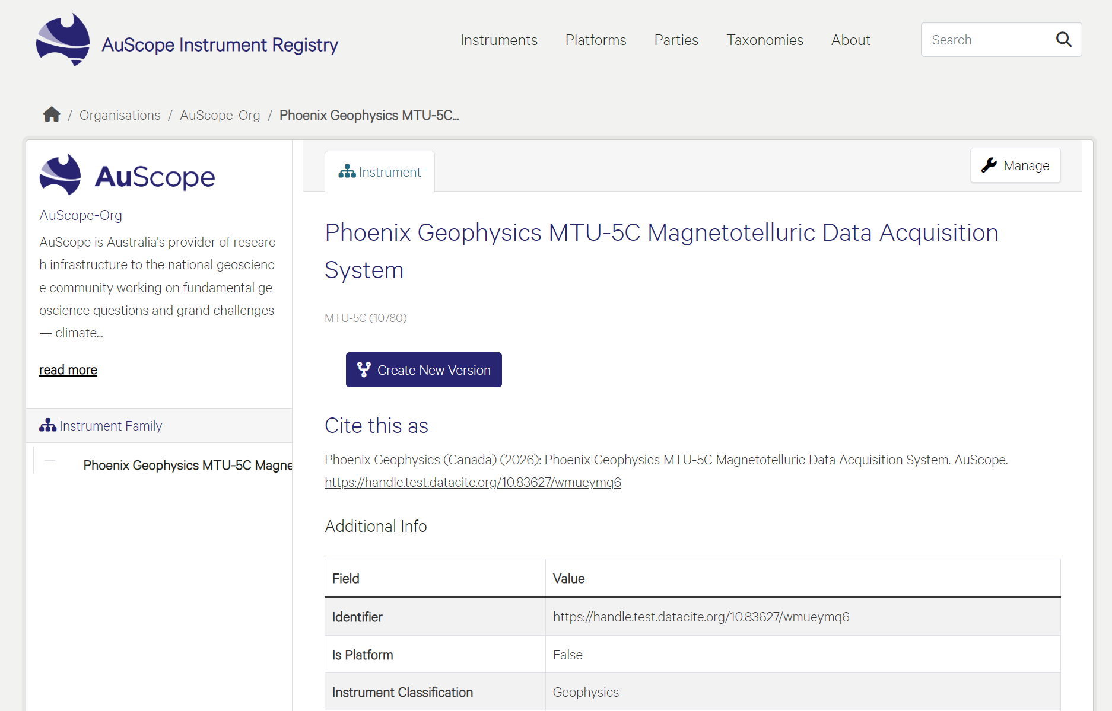
Figure 6 On the Instrument page, users can initiate the creation of a new version of the existing instrument.

The link between versions is recorded through the Related Identifiers field. When a new version is created, the new record references the previous version using the relationship type IsNewVersionOf. This relationship makes the version chain explicit in the metadata and supports consistent DOI-based navigation between related instrument records.
The version history view provides a clear record of all versions associated with an instrument. Users can use this view to move between versions and understand how the record has changed over time. If a user opens an older version, the application indicates that it is not the latest version and provides a pathway to the current version. This helps prevent users from accidentally relying on outdated metadata while still keeping previous published versions accessible for citation, audit, and provenance purposes.
This versioning model preserves the distinction between the physical instrument and the metadata records that describe it. The instrument remains the same real-world object, but each published metadata version represents a specific state of knowledge about that object at a point in time. This approach supports DOI governance, long-term traceability, and transparent management of changes across the AuScope Instrument Registry.

Platforms

Platforms Search
The search workspace is optimised to filter multi-instrument configurations using text-based queries, active filters, and dynamic sidebar facets.
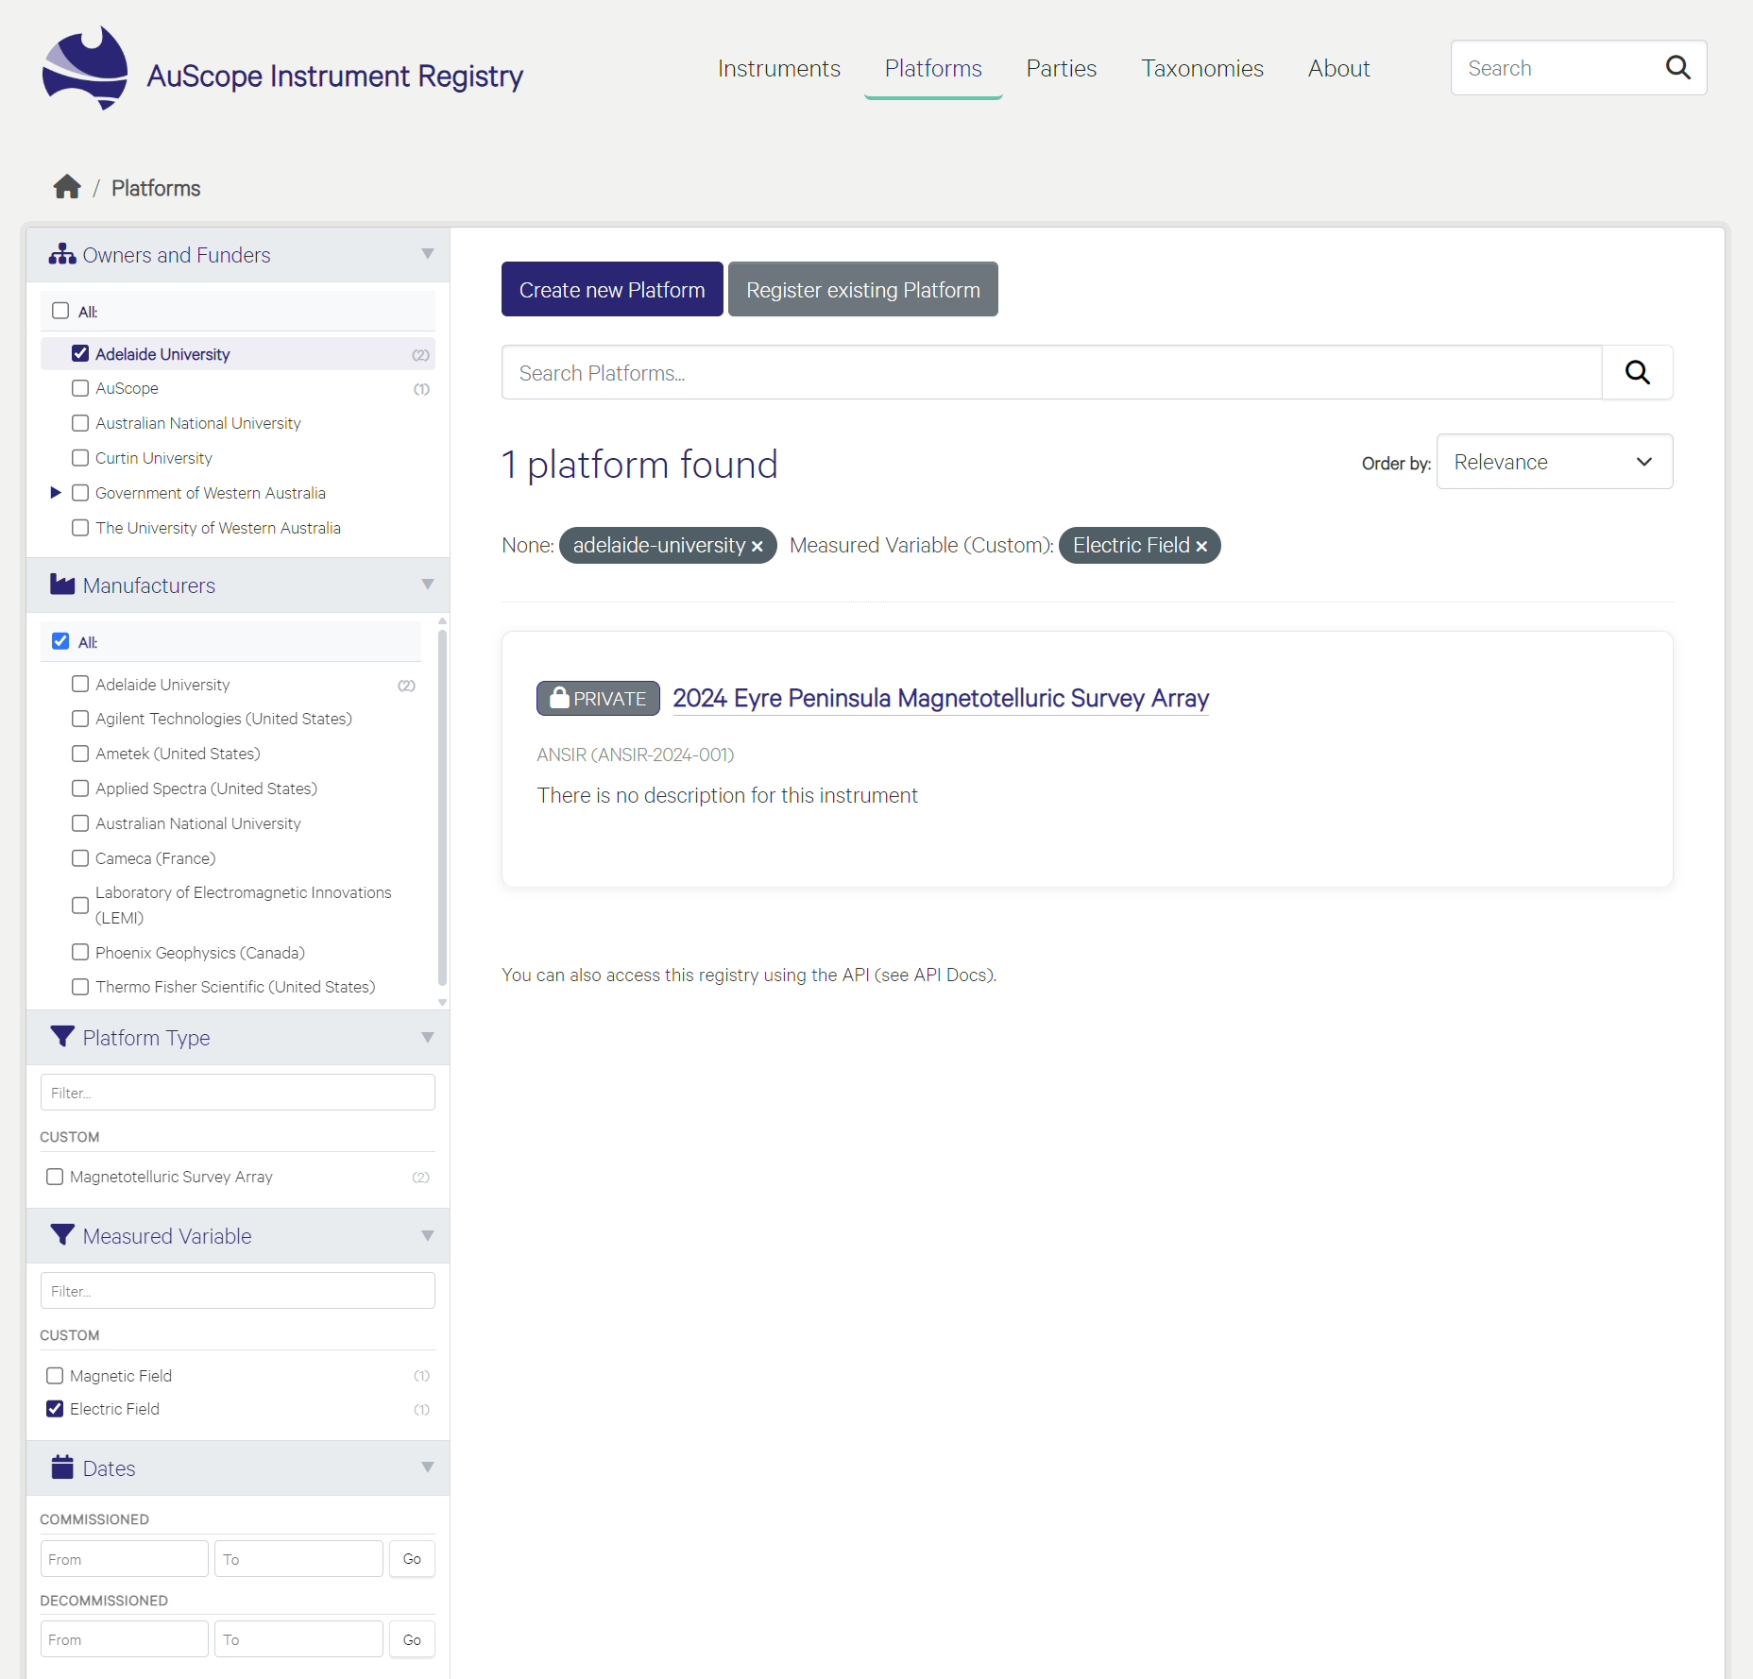
Figure 7 Platforms search interface.

Text Search and Query Matching
At the top centre of the page, a centralised search bar allows logged-in and public users to isolate configurations.
- Keyword Matching: Input text scans the database to find partial or absolute string matches across Platform Names, identifiers, and custom platform descriptions.
- Result Ordering: A dropdown menu in the upper-right corner prioritises results by Relevance, Name, or creation date.

Active Filter Pills
When user criteria are explicitly checked in the sidebar, they appear as graphical tags directly above the results feed.
- Dynamic Indicators: Each pill shows the selected category alongside its explicit metadata value.
- Instant Removal: Users click the close icon (x) on any individual pill to expand their search parameters.

Faceted Filter Panels
The left sidebar features collapsible facet blocks accompanied by specific record counts to help users refine their queries:
- Owners and Funders: Filters platforms by institutional owners or national funding initiatives (e.g., Adelaide University, AuScope).
- Manufacturers: Isolates systems based on the builders or laboratories responsible for the sub-components.
- Platform Type: Groups platforms by hierarchical taxonomy structures or specific geoscience survey methods (e.g., Magnetotelluric Survey Array).
- Measured Variable: Pinpoints configurations tracking specific environmental fields or physical phenomena (e.g., Magnetic Field, Electric Field).
- Dates: Refine results using dedicated calendar date pickers for Commissioned or Decommissioned operational timelines.
- Filter by Location: An interactive, embedded geospatial map widget allows geographic bounding-box filtering for field arrays.

Configuration Actions (Authorised Users Only)
Two administrative operation buttons sit directly above the main text search layout to manage workflows:
- Create New Platform: Opens a blank schema form to declare and document a completely fresh multi-device array.
- Register Existing Platform: Imports an active, pre-configured arrangement that already possesses a globally unique persistent identity without minting a separate identifier.

Create / Update / Delete Platforms
The Platforms interface enables users to configure, register, and manage arrays of scientific instruments that operate together as a unified system. This section covers the workflows for creating, modifying, and deleting platform profiles.

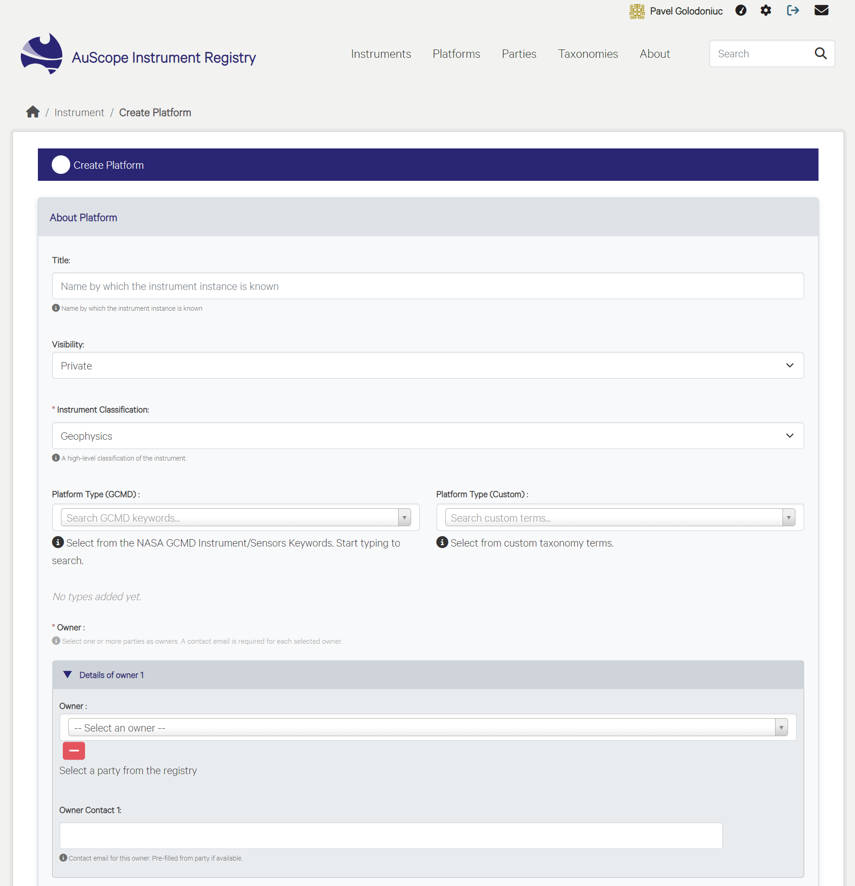
Figure 8 New Platform record creation interface

The Create Platform form provides a structured, multi-section web layout that allows authorised users to document a configuration of multiple instruments working together as a single system.
- Multi-Section Metadata Schema: The user interface groups platform properties logically into dedicated expandable cards—including About Platform details, Owner and Contact Information, Manufacturer Details, Model configurations, Date ranges, Measured Variables, Funding Sources, Alternate Identifiers, and Related Resources.
- Controlled Vocabulary Fields: Standardised dropdown menus link platform records directly with verified global vocabularies (e.g., NASA GCMD), internal custom taxonomies, and recognised stakeholder registries (Parties).
- Dynamic Component Management: Users can dynamically expand the entry form using operational controls (e.g., Add Owner, Add Manufacturer, Add Model, Add Date) to map multi-institution ownership, complex structural models, or varying lifecycles.
- Instrument Linking: A dedicated Related Instruments section allows users to search for and link individual physical devices or components that comprise the operational deployment system.
- Workflow Operations: Interactive action buttons at the bottom of the interface manage record status, allowing users to cancel changes, save data as a private workspace iteration, or complete the registration process to publish the platform profile.

A platform configuration is defined by linking a collection of individual instruments that work together as a unified measurement system. Users assemble this array in the Related Instruments panel using the autocomplete search bar to query existing assets by title, model, or serial number. Once selected, each connected device is explicitly logged and displayed as an active "Component" of the broader platform layout. This explicit relationship list ensures detailed configuration traceability and preserves data provenance across multi-device geoscience surveys.

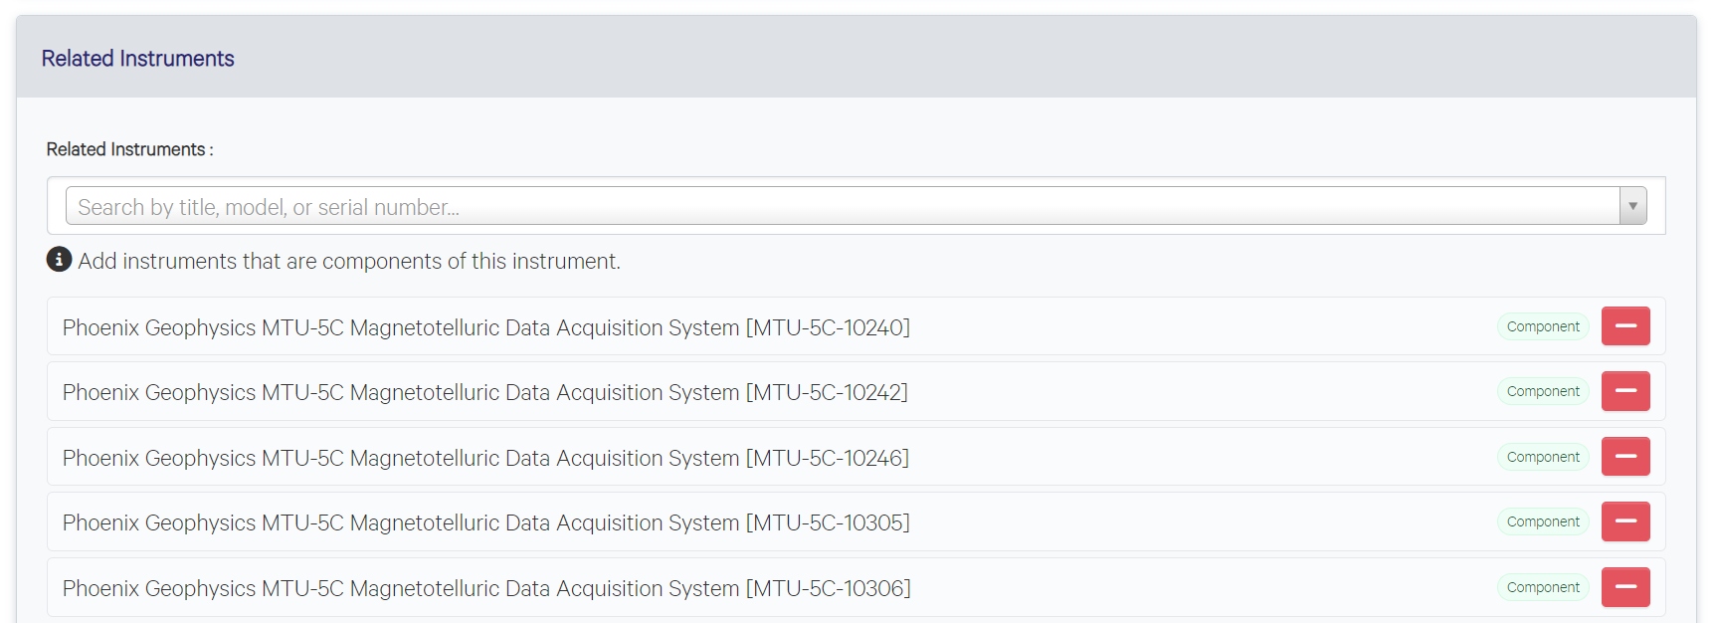
Figure 9 The list of Related Instruments that form a Platform

Parties
The Parties module provides a streamlined interface for managing organisational stakeholders, manufacturers, funders, and individual contacts associated with instruments and platforms. Party records act as controlled vocabulary entries that can be reused across the registry, ensuring consistent attribution and reducing duplication.

Parties Search and Browse
The Parties interface provides a simplified, lightweight way to quickly explore administrative stakeholders, equipment manufacturers, funding institutions, and technical contacts across the AuScope network.

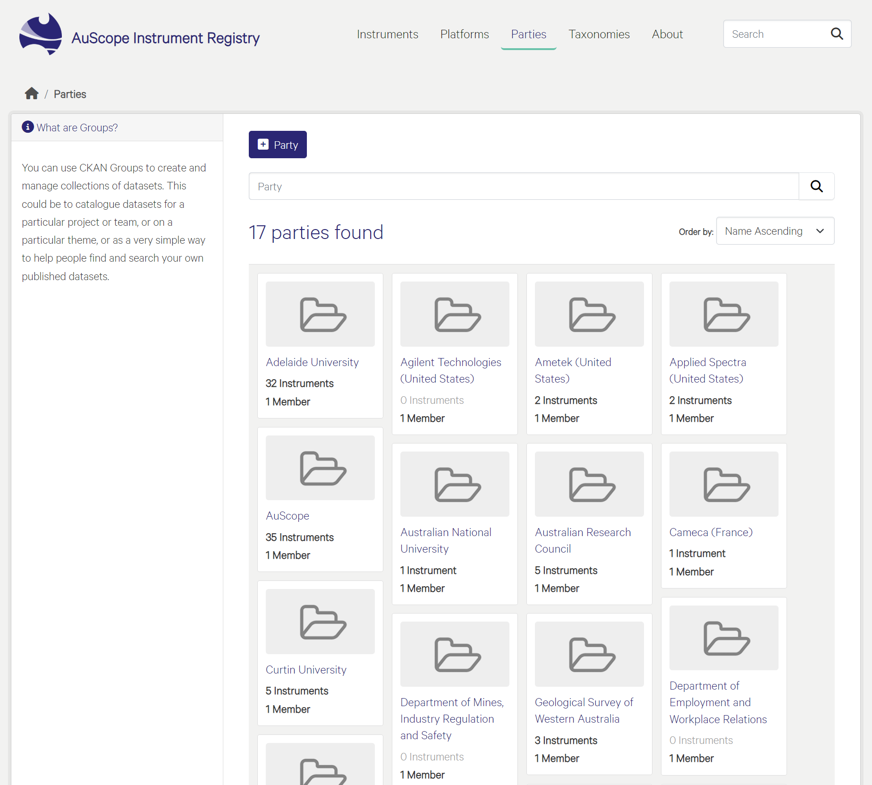
Figure 10 Simple Party browsing and search interface

Users can search the registry using a single text search bar that scans the database for keyword matches in organisation names and basic metadata. Search results can be ordered using the "Order by" dropdown menu to sort the organisation profiles alphabetically by name. Each matched profile is presented with key metrics, including the total number of registered instruments and registered Party members. This repository utilises underlying CKAN Groups, allowing users to consolidate datasets, coordinate project teams, and organise published metadata by organisational themes.

Create / Update / Delete a Party
Authorised users can create a new Party profile using the Add Party form. The interface presents a structured set of fields that capture the essential administrative and descriptive attributes of an organisation or individual. The layout mirrors the design patterns used across the registry, grouping related metadata into logical sections.
The Party creation form includes:
- Name and Identifiers: The primary Party name, optional aliases, and external identifiers such as ROR IDs.
- Roles: A selectable list of roles (e.g., Owner, Manufacturer, Funder) that define how the Party participates in the lifecycle of instruments and platforms.
- ROR search behaviour: The scope of the ROR organisation search depends on the selected Party roles. When the Party is assigned the Owner and/or Funder role, the ROR search is limited to registered organisations within Australia. If the Manufacturer role is selected, the ROR search is expanded globally to allow manufacturers from outside Australia to be identified and linked.
- Hierarchy and Organisation Type: Optional fields for parent–child organisational relationships and classification of the Party as a university, government agency, company, or individual.
- Location and Contact Details: Country, state, website, and contact information to support accurate attribution and external linking.
- Short Description: A concise summary describing the Party’s relevance to the AuScope network.

The form uses controlled vocabularies and dropdown selectors to maintain consistency across the registry. Once all required fields are completed, users submit the record using the Add Party button, which creates a new reusable Party entry.
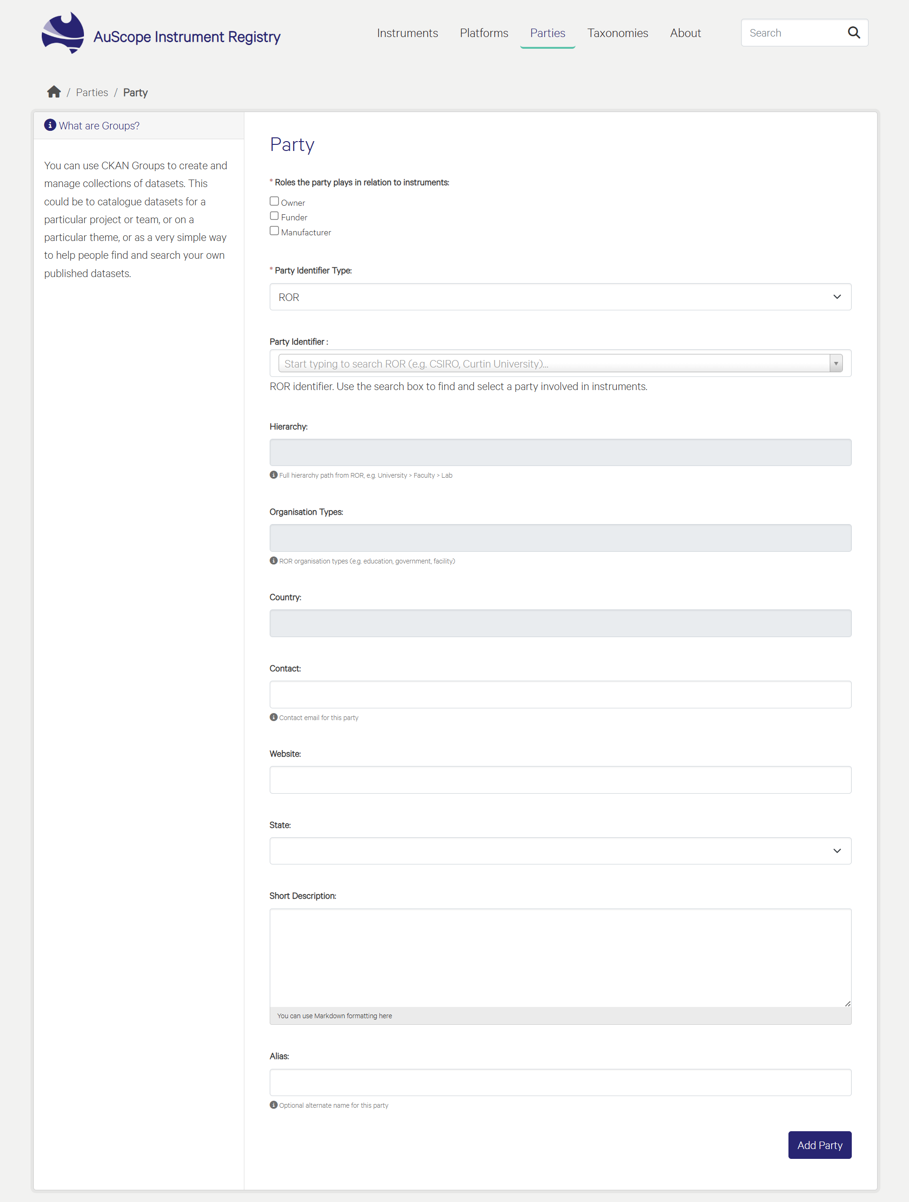
Figure 11 Party creation and editing interface

Existing Party records can be edited by authorised users to reflect organisational changes, updated contact details, or expanded role assignments. The update interface mirrors the creation form, allowing users to adjust any metadata field. This ensures that Party profiles remain accurate and aligned with current institutional structures.

Existing Party records can also be deleted from the Party’s Manage section. The delete function is available at the end of the Party management form through the Delete button. Deletion permissions are restricted to protect references to references between Parties and to registered instruments or platforms. A CKAN system administrator can delete any Party record. AuScope administrators can create Parties and can delete only the Parties they created themselves. Even where deletion is permitted, the system prevents removal if the Party is currently assigned to instruments. In this case, the Delete button remains visible, but the system displays an error advising the user to first remove or correct the existing references before the Party can be deleted.

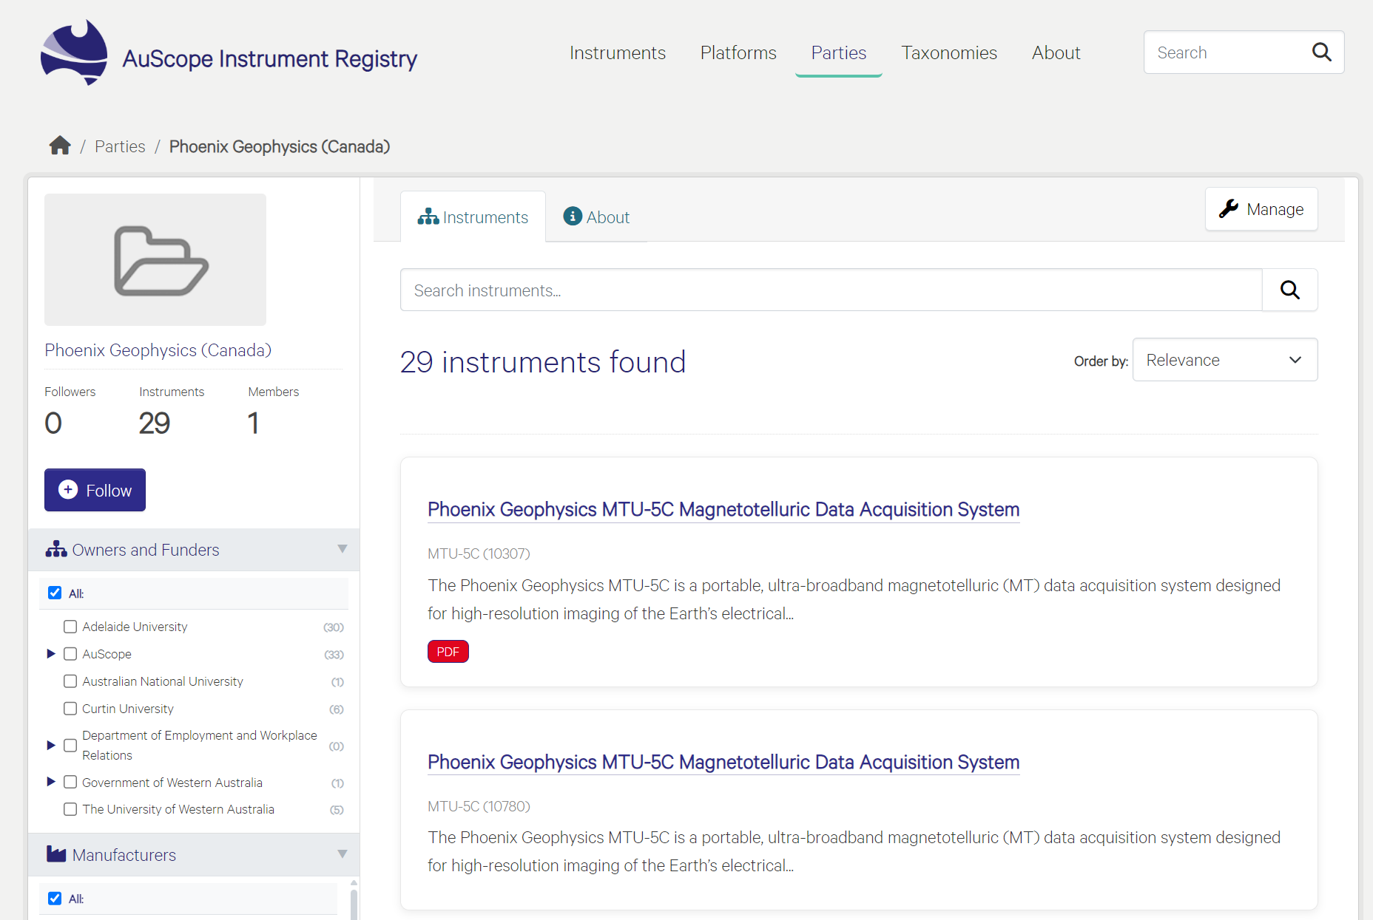
Figure 12 To manage an existing Party, click the "Manage" button at the top of the form.

Taxonomy
Taxonomies are controlled vocabularies that establish system-wide data consistency. Taxonomies provide hierarchical dictionaries for filtering and classifying hardware by scientific sector, instrument types, and measured environmental variables.

Taxonomy Search and Browse
The Taxonomies interface serves as the centralised classification directory, providing users with structured navigation across all controlled vocabularies in the registry. The interface provides a dual-framework classification system to ensure data uniformity and support advanced asset discovery across multiple scientific sectors.

Dual-Classification Framework
The directory is divided into two distinct indexing architectures to balance localised asset tracking with standardised global discovery frameworks:
- Custom Taxonomies: Hierarchical dictionaries managed internally by the registry to support custom organisational tracking.
- GCMD Taxonomies: Standardised environmental science keywords derived directly from the NASA Global Change Master Directory vocabulary service.
Where possible, users are encouraged to request the addition of missing terms to the GCMD vocabulary rather than creating equivalent custom taxonomy terms.

Search and Browsing Capabilities
The interface offers multi-layered navigational tools designed to streamline how users locate specific terminology:
- Dynamic Vocabulary Search: Individual text search fields allow users to filter structural terms and pinpoint obscure classifications instantaneously.
- Collapsible Tree Navigation: Interactive, multi-level dropdown hierarchies enable users to expand or collapse parent-child relationships between broader and narrower terms.
- Incremental Data Loading: Large datasets utilise on-demand pagination controls, allowing public and registered visitors to expand sub-vocabularies without degrading page performance.

Facet Filtering and Classification Levels
Both taxonomy frameworks organise system-wide terminology into three foundational classification streams to refine data entry and improve overall searchability:
- Instruments: Hardware classifications that index individual physical devices, sensors, etc.
- Platforms: Structural terminology mapping out combined multi-device survey arrays, satellite configurations, and operational deployment networks.
- Measured Variables: Granular physical properties, phenomena, or environmental metrics that the registered devices are explicitly configured to observe.

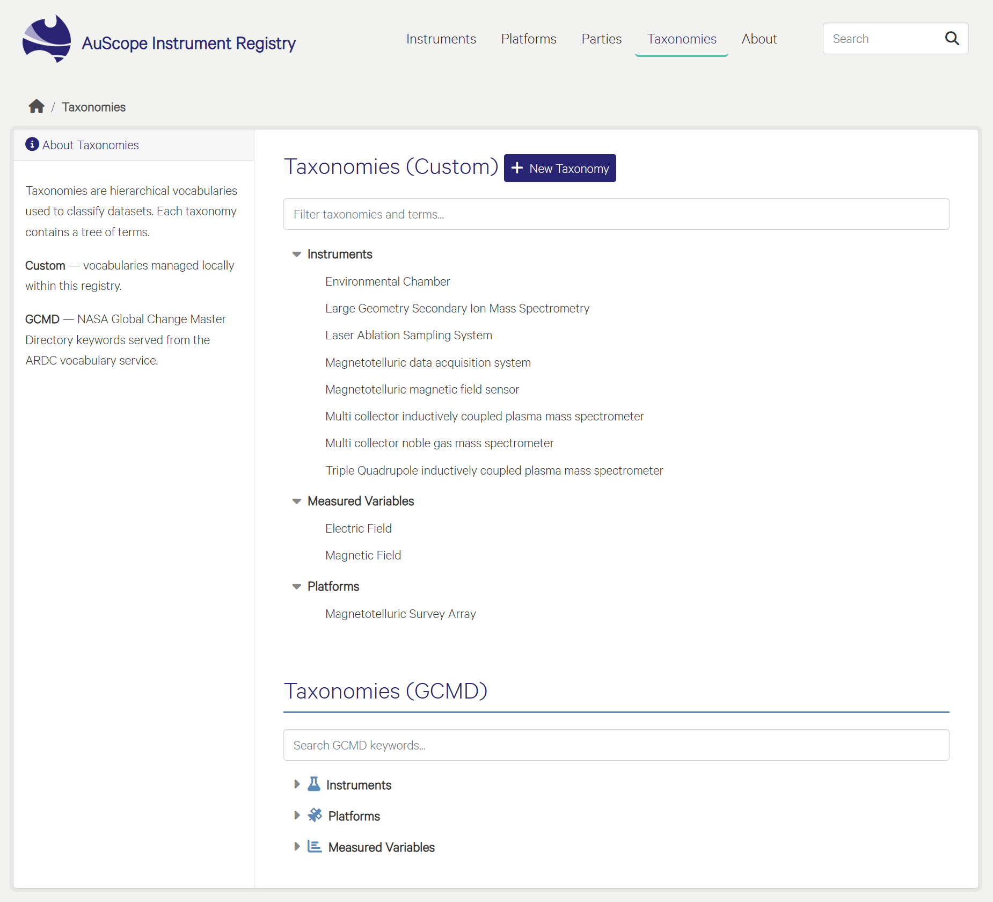
Figure 13 Taxonomies search and browsing interface

Create / Update / Delete a Taxonomy
The Taxonomies interface enables authorised users to create, expand, and modify hierarchical controlled dictionaries. This section provides a step-by-step workflow for establishing a new taxonomy registry and organising structured terms within it.

Initiating a fresh classification dictionary requires a high-level registration process. To create a completely new taxonomy structure:
- Navigate to the Taxonomies page from the main header and click the + New Taxonomy button.
- Title: Input a human-readable title that clearly establishes the scope of the controlled vocabulary.
- Name: Provide a unique system name. If left blank, the application will automatically generate this string from your title entry.
- URI: Users can optionally provide a custom, resolvable external URI to link this entry with broader vocabulary services. If left empty, the registry automatically mints a local, fully resolvable system URI.
- Click Create Taxonomy to commit the record.

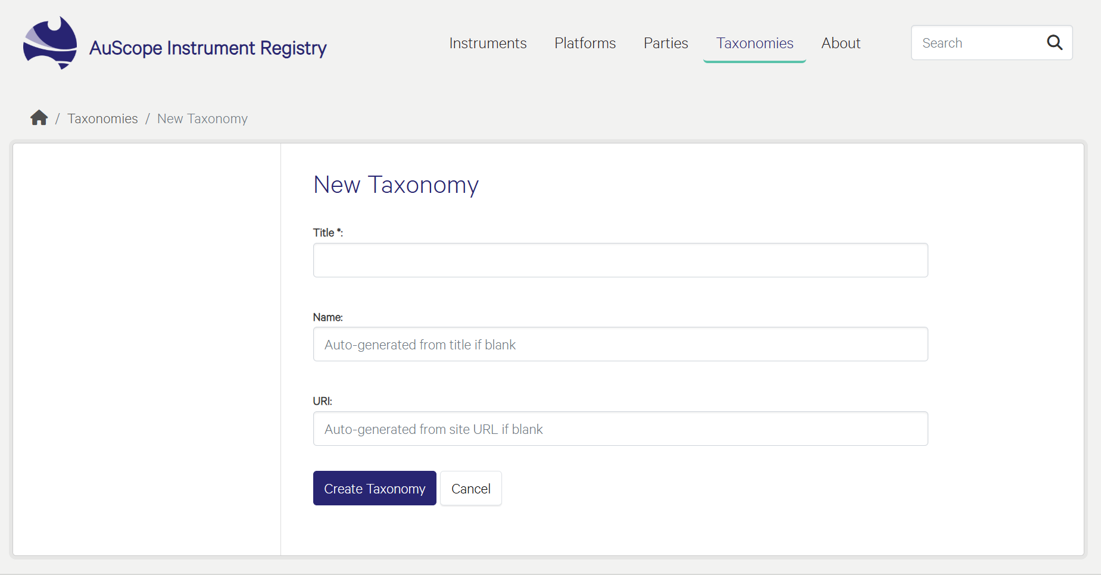
Figure 14 Creating a new Taxonomy interface

Once the parent taxonomy is generated, users can populate it with precise, multi-layered scientific terms. The registry supports deep hierarchical structuring, allowing terms to be nested safely within one another for complex data classification:
- Open your created taxonomy from the list view and click the + Add Child Term button.
- Label & Description: Enter the explicit scientific term label along with a concise description detailing its metadata application boundaries.
- URI & Extras: Just like the parent taxonomy, a resolvable URI is auto-generated upon saving unless a custom URI is manually supplied. Optional metadata properties can be added as a raw JSON object within the Extras block.
- Click Create Term to finalise registration.

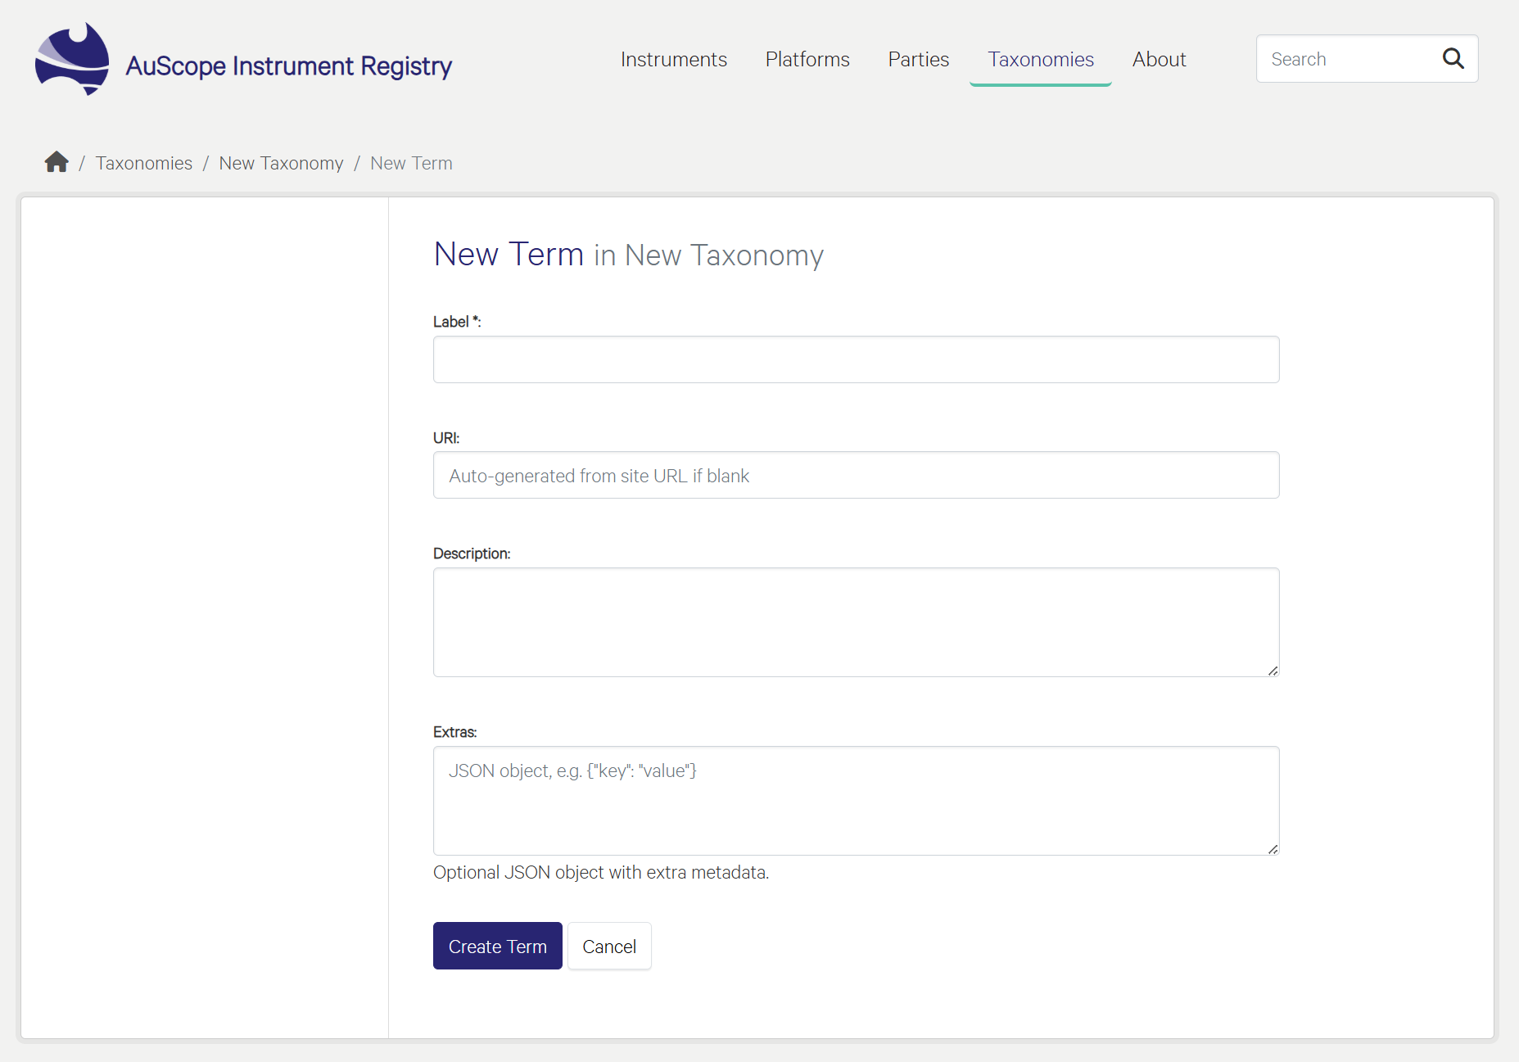
Figure 15 Creating a new Taxonomy Term interface

Controlled dictionaries are designed to be dynamic and can change as new geoscience sectors or instrumentation standards evolve:
- Modifying Metadata: Authorised administrators can select any active tree layer and click the Edit button to alter descriptive labels, adjust parental nesting structures, or append structural JSON key-value pairs.
- Removing Classifications: To completely remove a taxonomy or a specific nested branch from the active workspace, click the red Delete button.

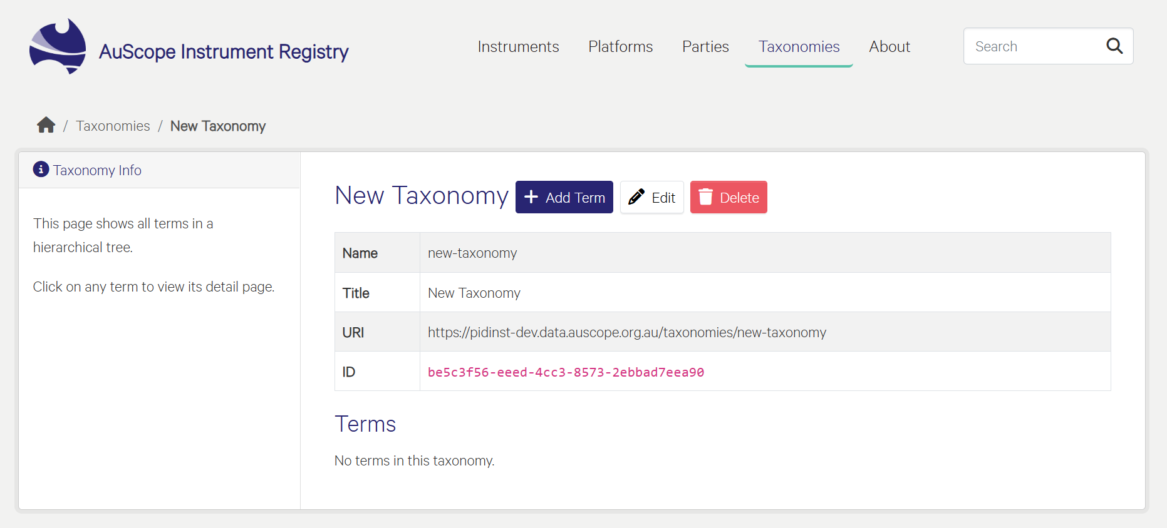
Figure 16 Taxonomy editing interface

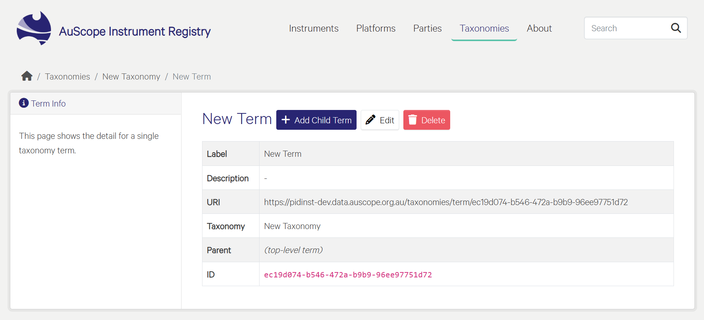
Figure 17 Taxonomy Term editing interface

New Taxonomy Terms will immediately appear in the Taxonomies (Custom) section of the Taxonomies page. New Taxonomy Terms can be added directly from this interface to the root taxonomy or as a child of another Term using the “+” button. Likewise, existing Terms can be edited or removed from the Taxonomy using the respective buttons.
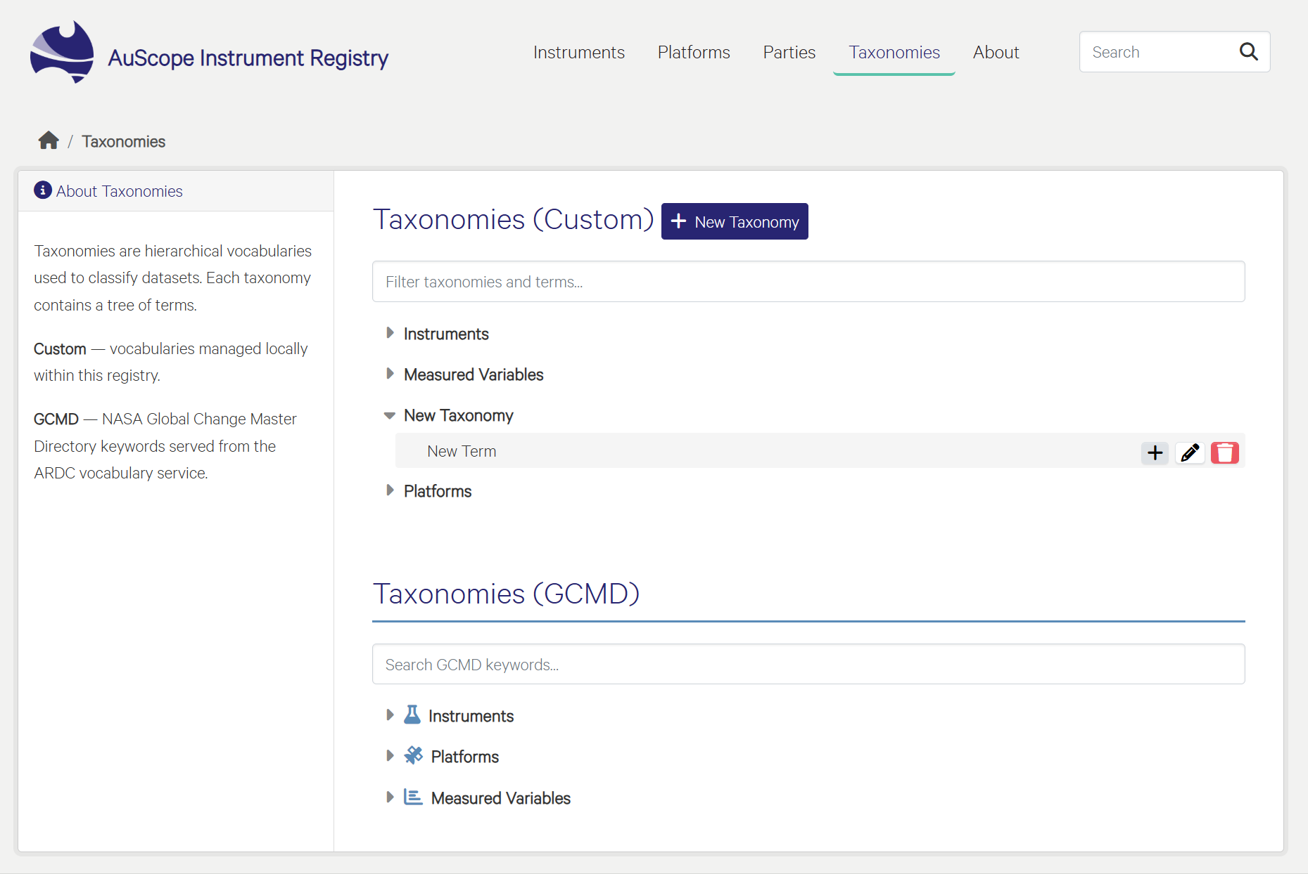
Figure 18 New Taxonomy is displayed in the list of Taxonomies with options to add new terms, edit and delete existing terms

References
[1] Krahl, R., Darroch, L., Huber, R., Devaraju, A., Klump, J., Habermann, T., Stocker, M., & The Research Data Alliance Persistent Identification of Instruments Working Group members. (2021). Metadata Schema for the Persistent Identification of Instruments. Research Data Alliance. https://doi.org/10.15497/RDA00070
[2] https://datacite-metadata-schema.readthedocs.io/en/4.6/mappings/pidinst/
As Australia’s national science agency and innovation catalyst, CSIRO is solving the greatest challenges through innovative science and technology.  CSIRO. Unlocking a better future for everyone.  Contact us  1300 363 400  +61 3 9545 2176  csiro.au/contact  csiro.au |  | For further information  Mineral Resources  Pavel Golodoniuc  pavel.golodoniuc@csiro.au  Mineral Resources  Benyamin Motevalli  benyamin.motevalli@csiro.au  Mineral Resources  Neda Taherifar  neda.taherifar@csiro.au

